PSP0201

WEEK 2

WRITE-UP

GROUP NAME : PELITA

| ID | Name | Role |
| --- | --- | --- |
| 1211102057 | Muhammad Syahir Nazreen Bin Abdul Hamid | Leader |
| 1211101935 | Mohamed Imran Bin Mohamed Yunus | Member |
| 1211103220 | Muhammad Firzan Ruzain Bin Firdus | Member |
| 1211102060 | Farris Aiman Bin Mohd Harris | Member |

# Day 1: A Christmas Crisis

**Tools used: Kali, Mozilla**

**Solution/walkthrough:**

Question 1

Opened the Christmas Control Centre website.

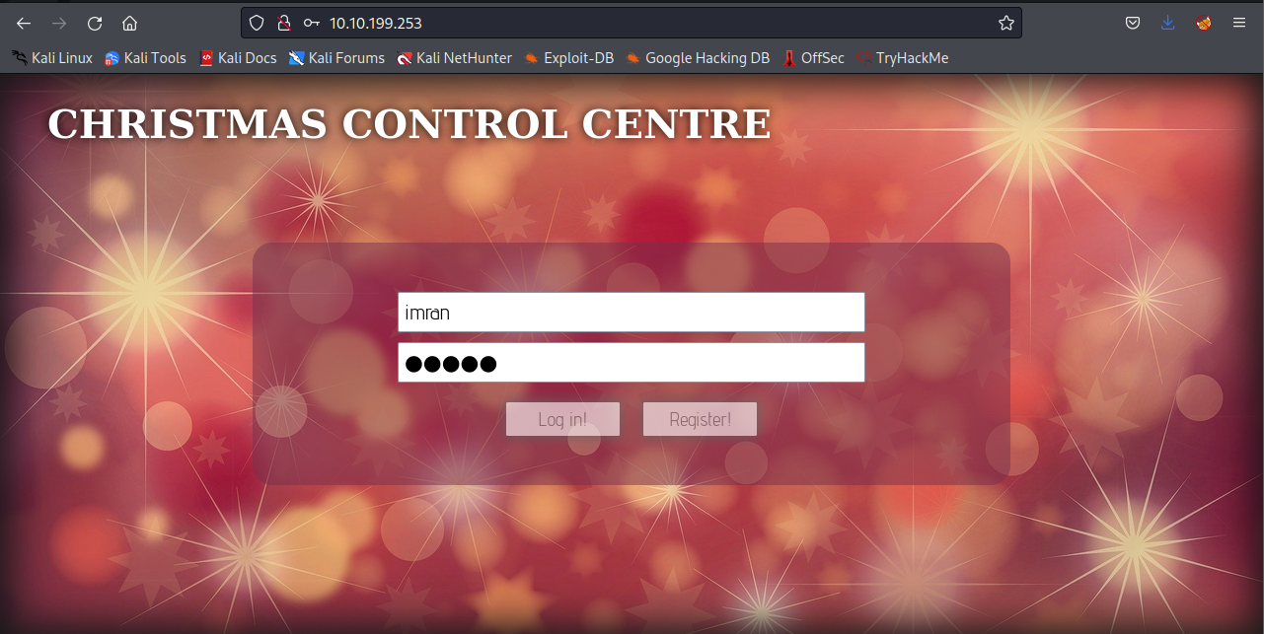

Question 2

Registering and logging in to the Christmas Control Centre.



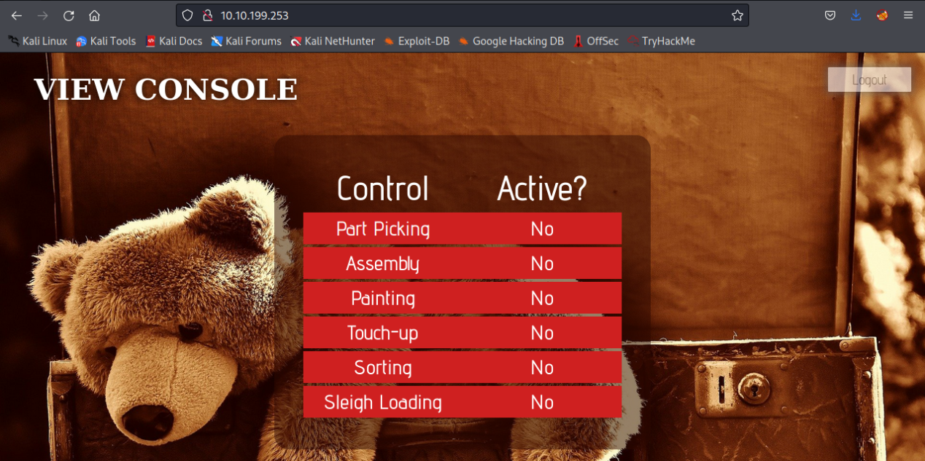

Checking the cookie. The name of the cookie is auth.

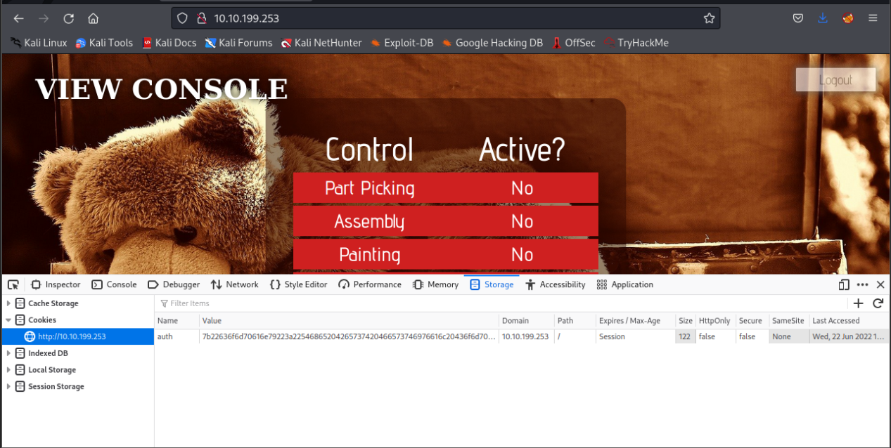

Question 3

By looking at the value, the cookie is encoded by Hexadecimal.

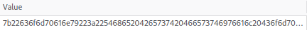

Question 4

Used Cyberchef to convert the cookie to string. The Input is In JSON format.

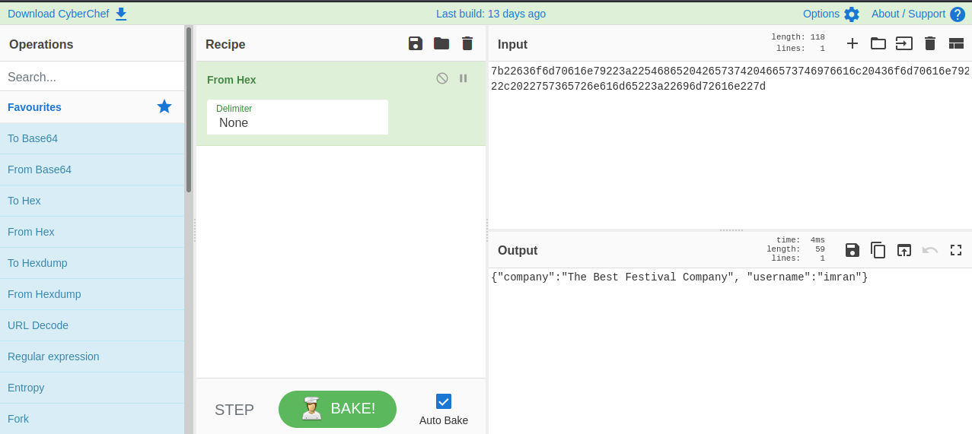

Question 5

The value of the company found inside the cookie.



Question 6

There is also username inside the cookie.



Question 7

Changed The username to Santa and converted the string into value.

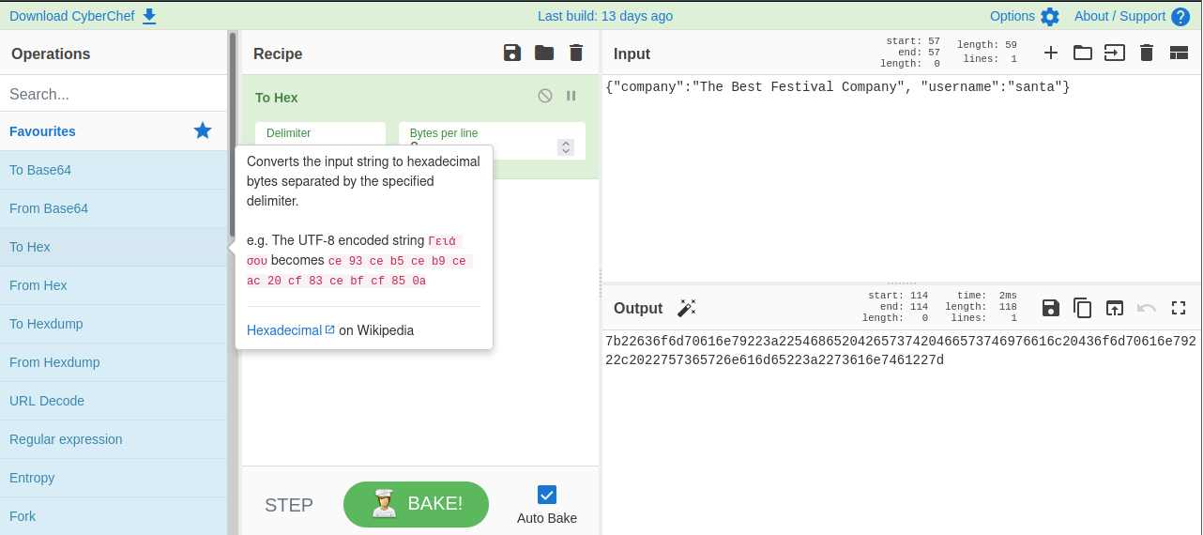

The Value of Santa’s cookie.



Question 8

After gaining the access, switching on every control shows the flag.

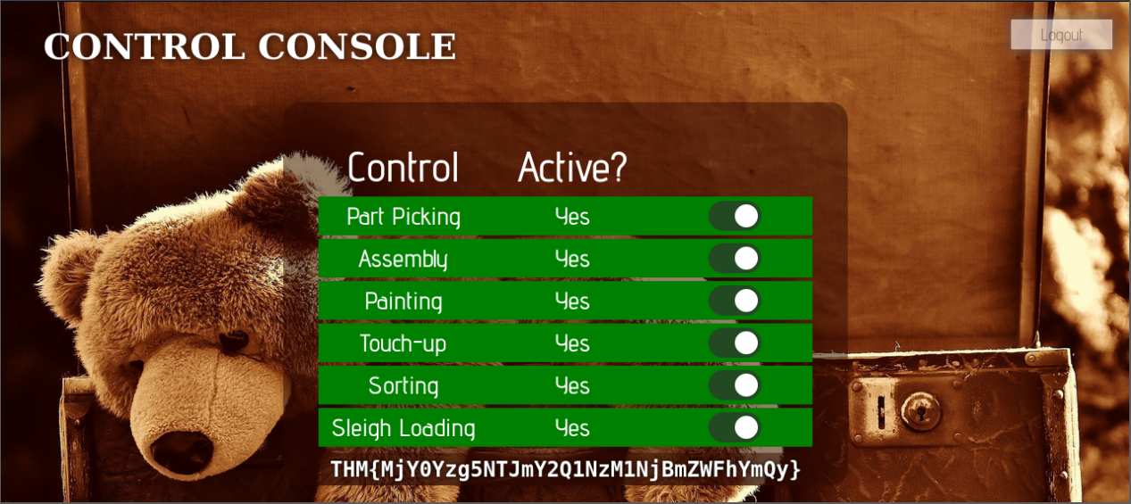

**Thought Process/Methodology:**

The accessed target machine directed to login/registration page. We registered and logged into the page. After directed to View Console page, we accessed the developer tools to show the website cookie from storage tab. The cookie value indicates that the value is encoded by hexadecimal. By converting it using CyberChef, we get a JSON string with username and company elements. Changed the username to “santa” and converted it back to Hexadecimal value. Replaced the cookie value on view console page with the new one. By refreshing the page we gained access to the control as “santa”. Activating all the control shows the flag.

# Day 2: [Web Exploitation] The Elf Strikes Back

**Tools used: Kali, Mozilla, Netcat**

**Solution/walkthrough:**

Question 1

Upload Page has been accessed by adding **?id=ODIzODI5MTNiYmYw** to the URL.

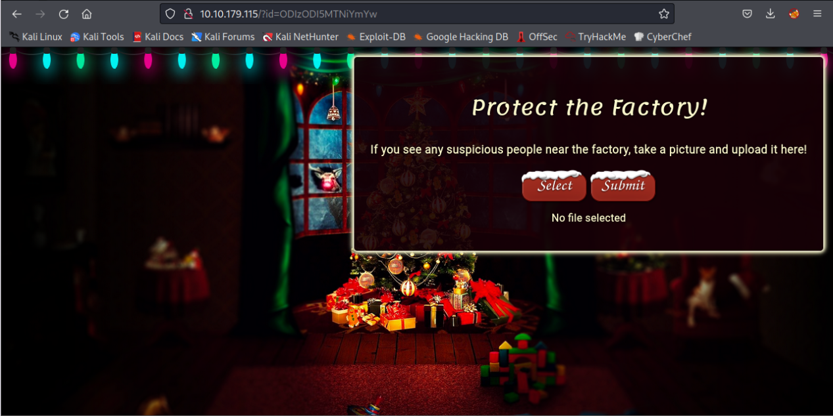

Question 2

By clicking on View Page Source at the site, we get to know which type of file is accepted to upload. We understood that we can bypass the page by uploading a double-barrelled extension (e.g. .jpg.php)

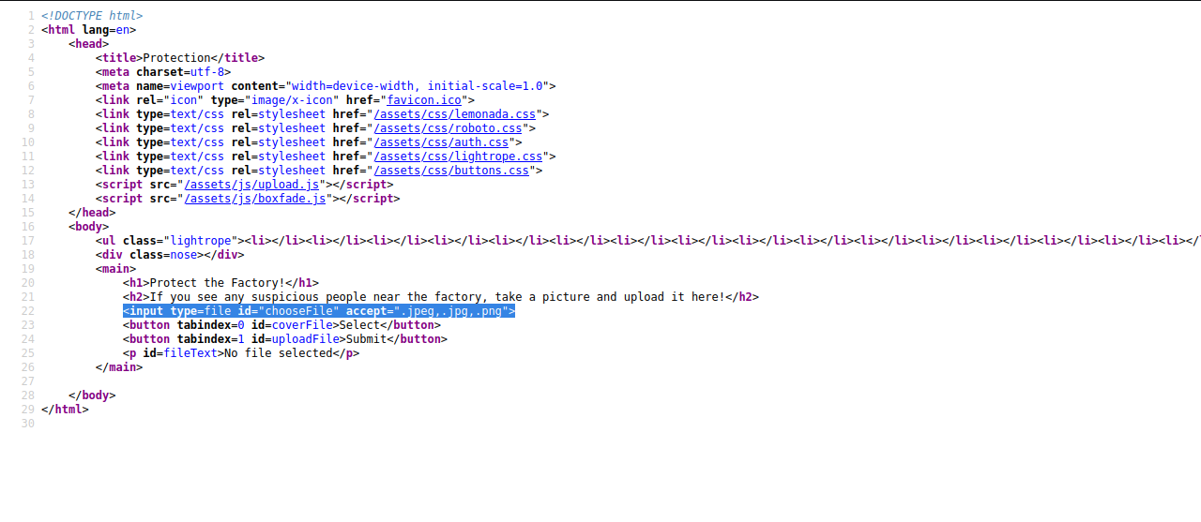

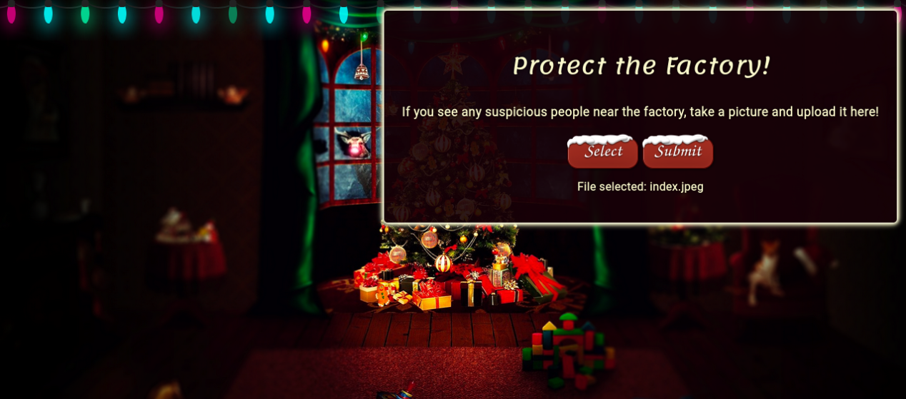

Question 3

The files are uploaded in **/uploads/** directory.

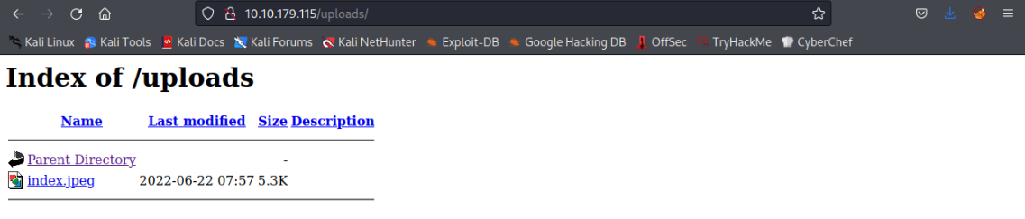

Question 4

The netcat parameter explanation can be found by using **sudo nc -help** command on the terminal. We get to know the meaning of **l**, **v**, **n** and **p** parameter.

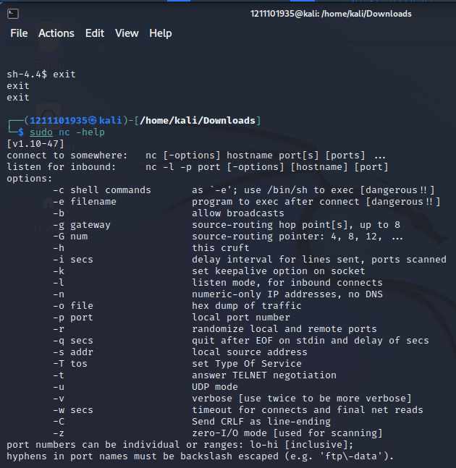

Question 5

Copied the webshells into the current directory. PHP reverse-shell file has been created.

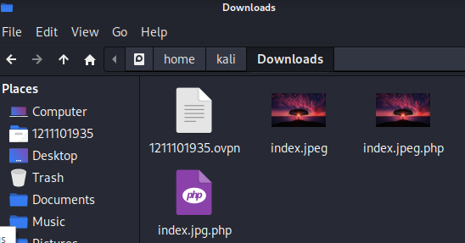

Opened the PHP file with nano. IP address has been changed to Machine IP, the port changed to 443 .

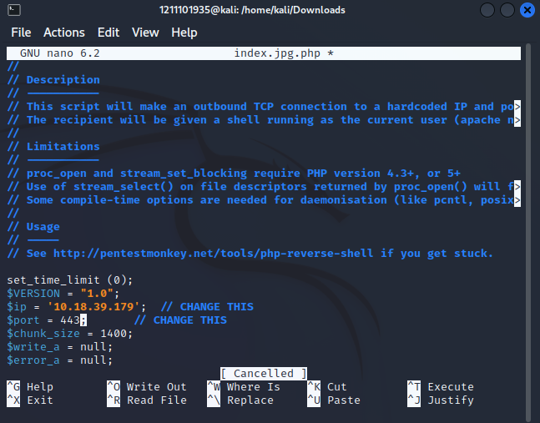

Uploaded the PHP file.

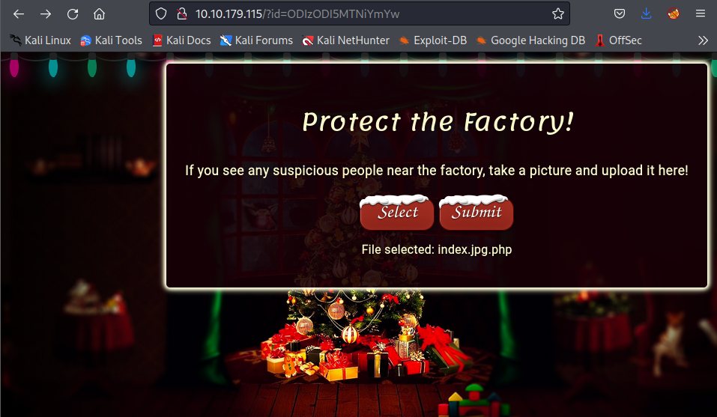

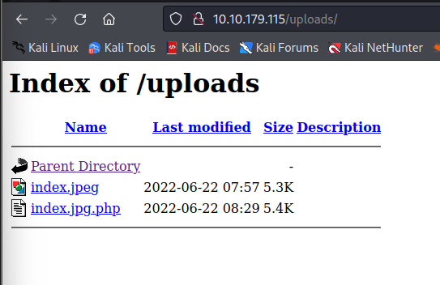

Connected to the netcat listener.

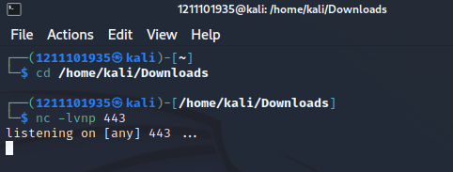

Clicked on the uploaded PHP file.

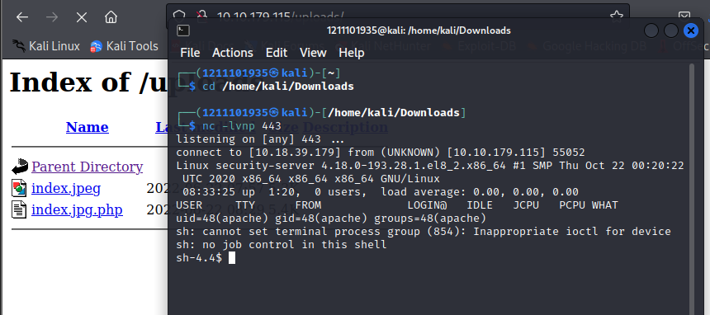

Opened the **/var/www/flag.txt** and the flag is there.

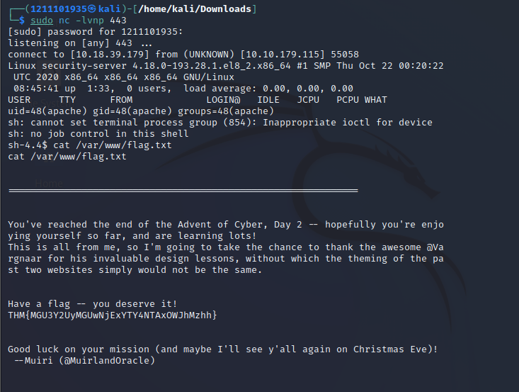

**Thought Process/Methodology:**

The upload section site is accessed through the assigned ID **ODIzODI5MTNiYmYw.**

Clicked on the view page source to understand which type of file is accepted. We understood that we can bypass the page by uploading a double-barrelled extension (e.g. .jpg.php). By guessing the most common upload directory, we know that the uploaded file is stored in **/uploads/** directory. In order to listen the reverse shell, we used the Netcat listener. We went through the parameter explaination to understand which parameter is suitable for listening. By understanding the explanation we decided to use command **sudo nc -lvnp** tolisten the reserve shell file.

Copied the webshell to current directory and created a file with double-barrelled extension ( **index.jpg.php** ). Accessed the php file by using nano and changed the IP address to machine IP and the port to 443. Uploaded the php file and directed to the **/uploads/** directory. Clicked on the php file to let the netcat catch the reverse shell file. By gaining access, putting in the command cat /var/www/flag.txt we get the flag.

# Day 3: [Web Exploitation] Christmas Chaos

**Tools used: Kali, Mozilla, Burp Suite.**

**Solution/walkthrough:**

Question 1

From the given text, we know the botnet is called **Mirai**.

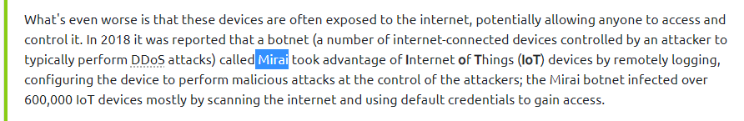

Question 2

The Starbucks company paid 250 USD reporting default credentials.



Question 3

The link <https://hackerone.com/reports/804548/> provides that, a U.S.Dept of Defense have disclosed the report on Jun 25th.



Question 4

Open Burp suite

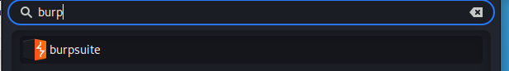

Add Foxy Proxy extension on Mozilla. Open the option.

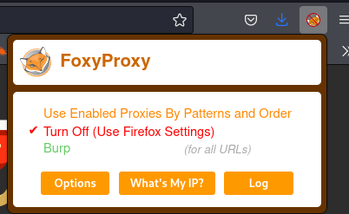

Click on Edit beside the Burp.

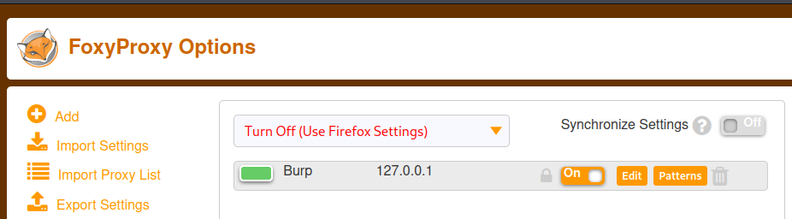

The port number can be found .

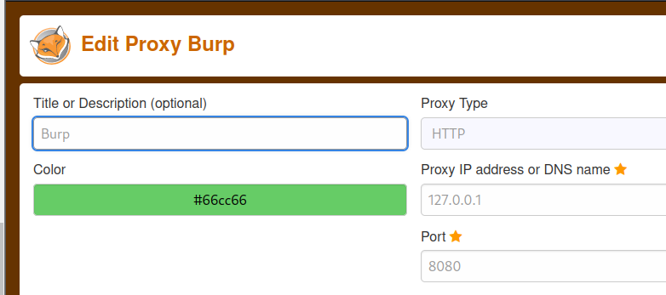

Question 5

The Proxy type is HTTP.



Question 6

The URL Encoding for ‘PSP0201’on Burp Suite

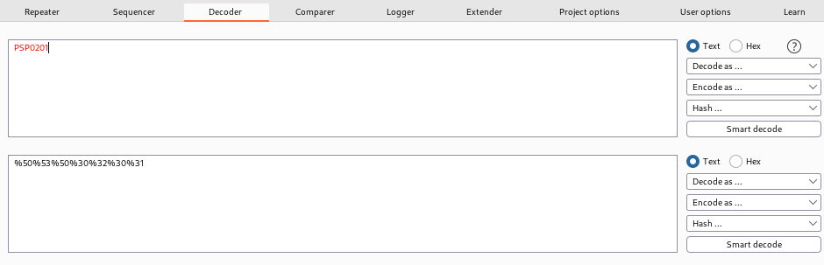

Question 7

**Cluster Bomb**. Uses multiple payload sets. Different payload for each defined position up to maximum 20. Iterates through each payload set in turn, so all permutations of payload combinations are tested.

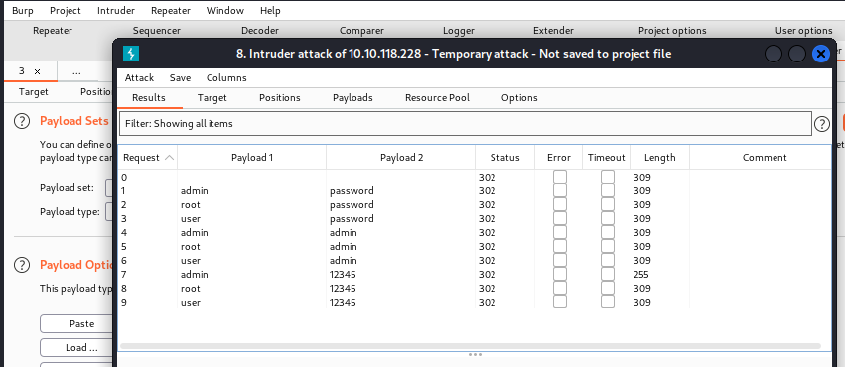

Question 8

Upon logging in using the username: admin and password: 12345. **The flag** will be shown in the directed website.

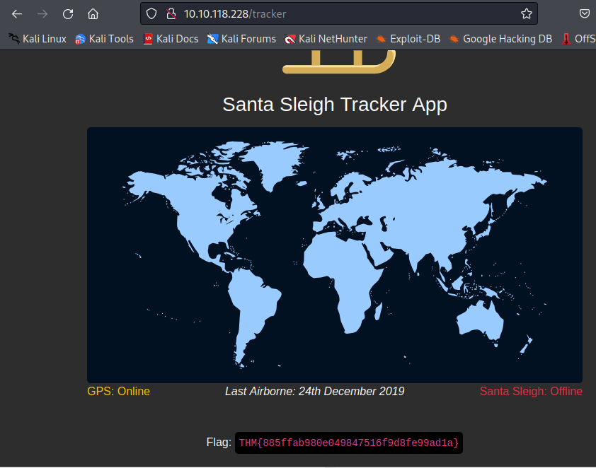

**Thought Process/Methodology:**

Through reading the default credentials notes on the website we get to know that the name of botnet which was reported on 2018 is Mirai. Some companies like Starbucks has became victim to the attack by leaving services running with default credentials and the bug hunter who reported the problem was awarded $250 USD.

The case of Mirai has been closed by a US Department of Defense agent ag3nt-j1 on 25th Jun. We added the FoxyProxy extension to Mozilla and examine the option for Burp. By doing this we know that the port number for Burp is 8080 and the proxy type is HTTP. Furthermore, we run Burp suite on Kali, opened the decoder tab to encode the string ‘PSP0201’into URL value. We begin our project by copy and pasting the machine IP address on browser search bar. After being directed to the page the Foxy Proxy is changed to Burp. Entered the username and password. Forwarded the intercept to capture the username and password on Burp Suite. Lauched multiple attack by guessing the username and password on payload tab. By testing multiple pay loads, we deduced that the cluster bomb Uses multiple payload sets. Different payload for each defined position up to maximum 20. Iterates through each payload set in turn, so all permutations of payload combinations are tested. After gaining the username as admin and password as 12345. we signed in to the plag to receive the flag.

# Day 4 [Web Exploitation] Santa's watching

**Tools used: gobuster, wfuzz, kali**

**Solution/walkthrough:**

Question 1:

Given the URL "http://shibes.xyz/api.php", what would the entire wfuzz command look like to query the "breed" parameter using the wordlist "big.txt" (assume that "big.txt" is in your current directory)

**wfuzz -c -z file,big.txt http://shibes.xyz/api.php?breed=FUZZ**

Question 2:

Use GoBuster (against the target you deployed -- not the [shibes.xyz](http://shibes.xyz/) domain) to find the API directory. What file is there?

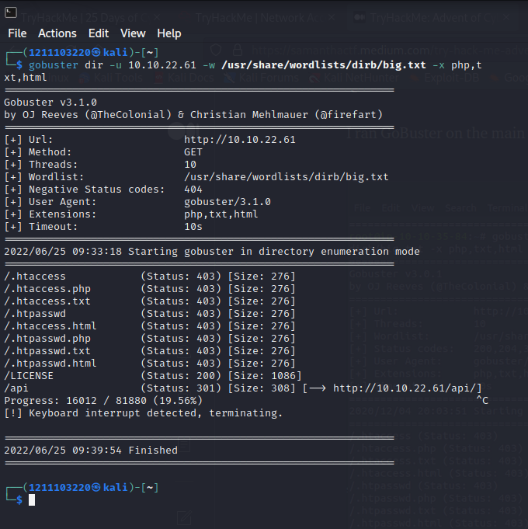

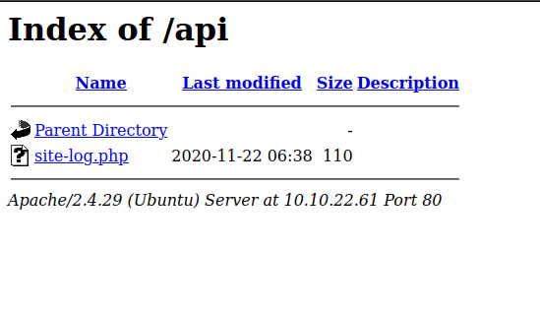

File found : **site-log.php**

Question 3:

Fuzz the date parameter on the file you found in the API directory. What is the flag displayed in the correct post?

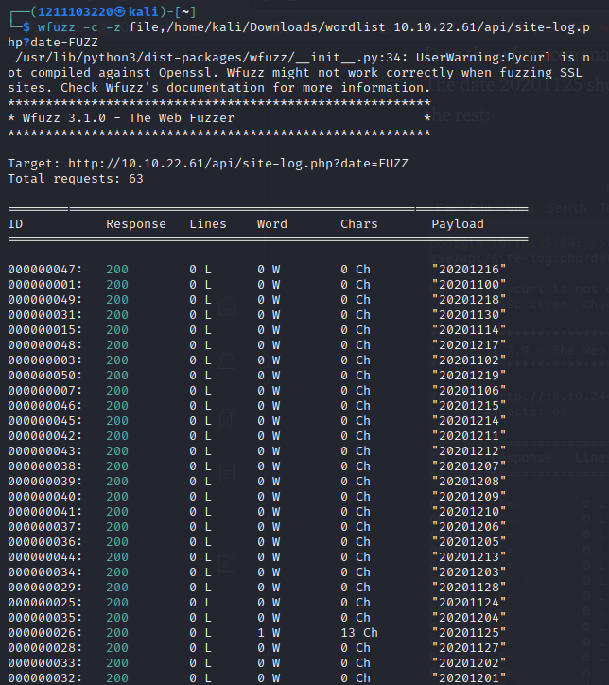

**The date 20201125 has 13 characters and is unique compared to the others.**

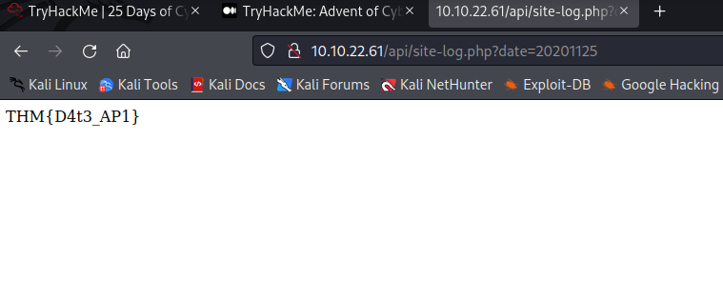Flag: **THM{D4t3_AP1}**

Question 4:

Look at wfuzz's help file. What does the -f parameter store results to?

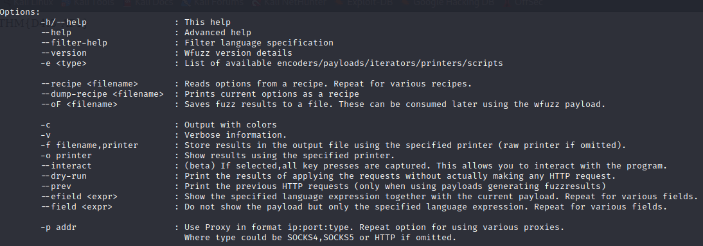

Answer: filename, printer

**Thought Process/Methodology:**

Gobuster were used firstly to determine the sub-directory of the ip domain. Alongside Gobuster the file “big.txt” is used as the wordlist. After the gobuster was run, it is detected that the sub-directory “/api” has a status of “301” with size of “308” giving us the hint that we can find something through the link. Upon opening the link we found a directory with a file in it named “site-log.php”. Next, the wfuzz command was used with a wordlist prepared by THM as containing random dates to be filled into the date parameter. The command was run and we found out that the date “20201125” contained 1 line and 13 characters and was unique compared to the other dates. The link alongside the given date parameter was visited and the THM flag was achieved.

# Day 5 [Web Exploitation] Someone stole Santa's gift list!

T**ools used: SQL Injection, sqlmap, burpsuite**

**Solution/walkthrough:**

Question 1:

What is the default port number for SQL Server running on TCP?

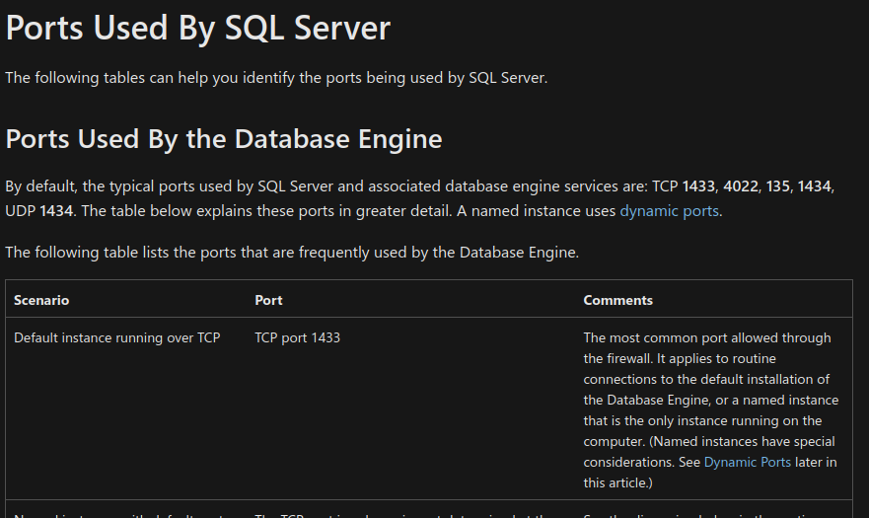

Answer: **1433**

Question 2:

Without using directory brute forcing, what's Santa's secret login panel?

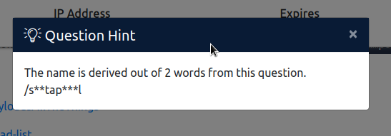

Based on the hint we can guess the answer for the santa login panel.

Answer: **/santapanel**

Question 3:

What is the database used from the hint in Santa's TODO list?

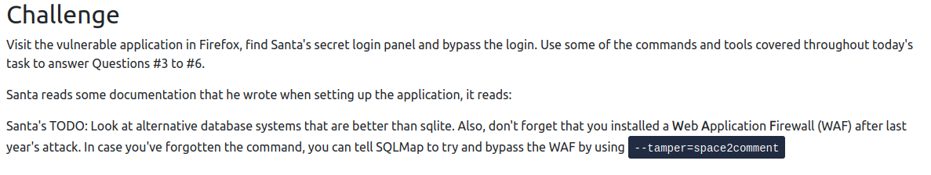

Answer: Based on the Santa’s TODO list the database used is **sqlite**

Question 4:

How many entries are there in the gift database?

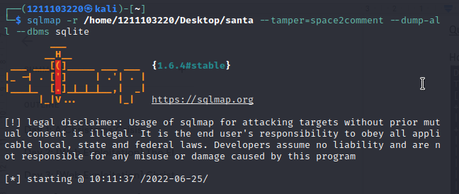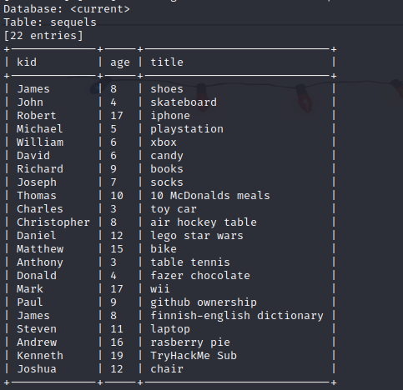

Answer: 22

Question 5:

What is James' age?

Answer: 8

Question 6:

What did Paul ask for?

Answer: github ownership

Question 7:

What is the flag?

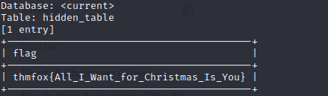

Answer: thmfox{All_I_Want_for_Christmas_Is_You}

Question 8:

What is the admin's password?

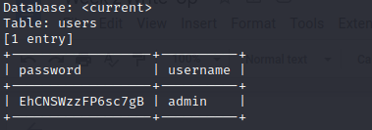

Answer: EhCNSWzzFP6sc7gB

**Thought Process/Methodology:**

Based on the microsoft documentation there are many known default TCP ports but the main one is 1433. A machine ip was given and the sub-domain for the Santa’s secret login panel could be guessed by the hint given since there is no directory brute forcing allowed. It is determined that the sub-domain is “/santapanel”. Based on the challenge explanation and hints it is given that Santa is trying to find alternatives databases other than sqlite, from that information we could determine that the database Santa is currently using is sqlite. After we login through the login panel with sql injection, we can continue using sqlmap to go through the database and get all the information. We found out the total entries are 22. From the list we can determine James is 8 years old and Paul asks for a github ownership. A hidden table is shown and alongside we achieved the THM flag. Last but not least we get the admin table with the username and the password.